**Name: Prn: Roll no.:**

**Riya Bambal 1032210504 24**

**Raina Basu 1032210519 27**

**Devanshu Surana 1032210755 50**

**Pranav Pisal 1032210794 56**

**Abhilash Kashid 1032210826 63**

**HDFS Commands:**

# version

## Hadoop HDFS version Command Usage:

version

## Hadoop HDFS version Command Example:

hadoop version

## Hadoop HDFS version Command Description:

The Hadoop fs shell command **version** prints the Hadoop version.

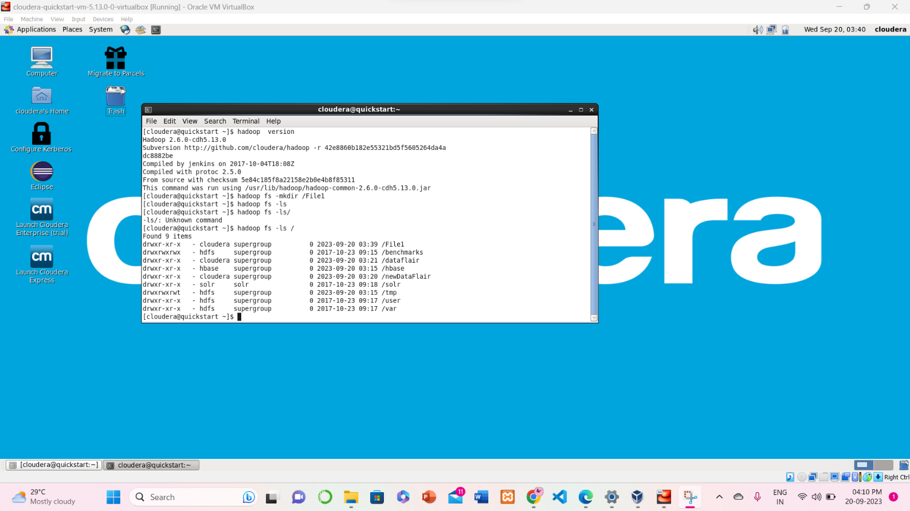

# mkdir

## Hadoop HDFS mkdir Command Usage:

hadoop fs –mkdir /path/directory_name

## Hadoop HDFS mkdir Command Example 1:



**Hadoop HDFS mkdir Command Description:**

This command creates the directory in HDFS if it does not already exist.

**Note:** If the directory already exists in HDFS, then we will get an error message that file already exists.

Use **hadoop fs mkdir -p /path/directoryname**, so not to fail even if directory exists.

# ls

## Hadoop HDFS ls Command Usage:

hadoop fs -ls /path



The Hadoop fs shell command **ls** displays a list of the contents of a directory specified in the path provided by the user. It shows the name, permissions, owner, size, and modification date for each file or directories in the specified directory.

**Hadoop HDFS ls Description:**

This Hadoop fs command behaves like **-ls,** but recursively displays entries in all subdirectories of a path.

# put

## Hadoop HDFS put Command Usage:

haoop fs -put <localsrc> <dest>

The Hadoop fs shell command **put** is similar to the **copyFromLocal**, which copies files or directory from the local filesystem to the destination in the Hadoop filesystem.

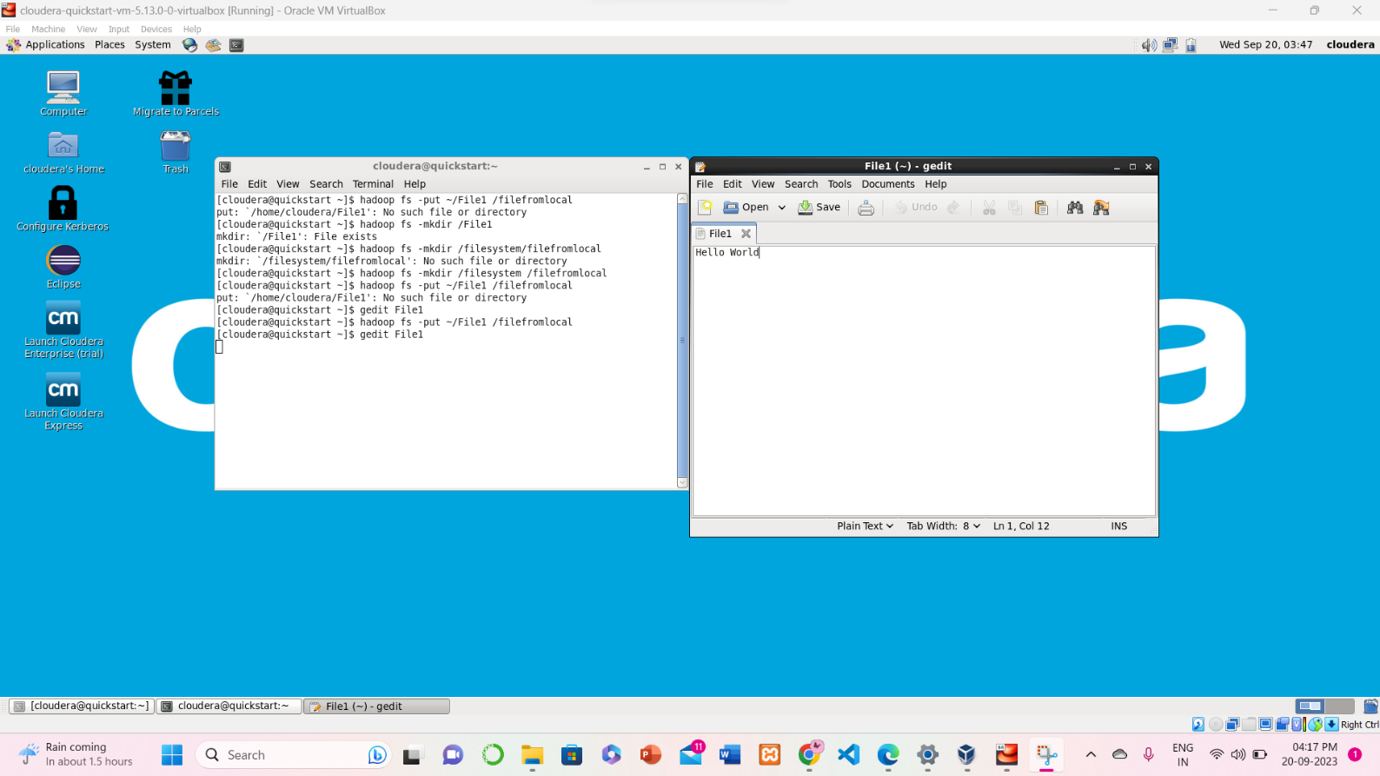

# copyFromLocal

## Hadoop HDFS copyFromLocal Command Usage:

hadoop fs -copyFromLocal <localsrc> <hdfs destination>

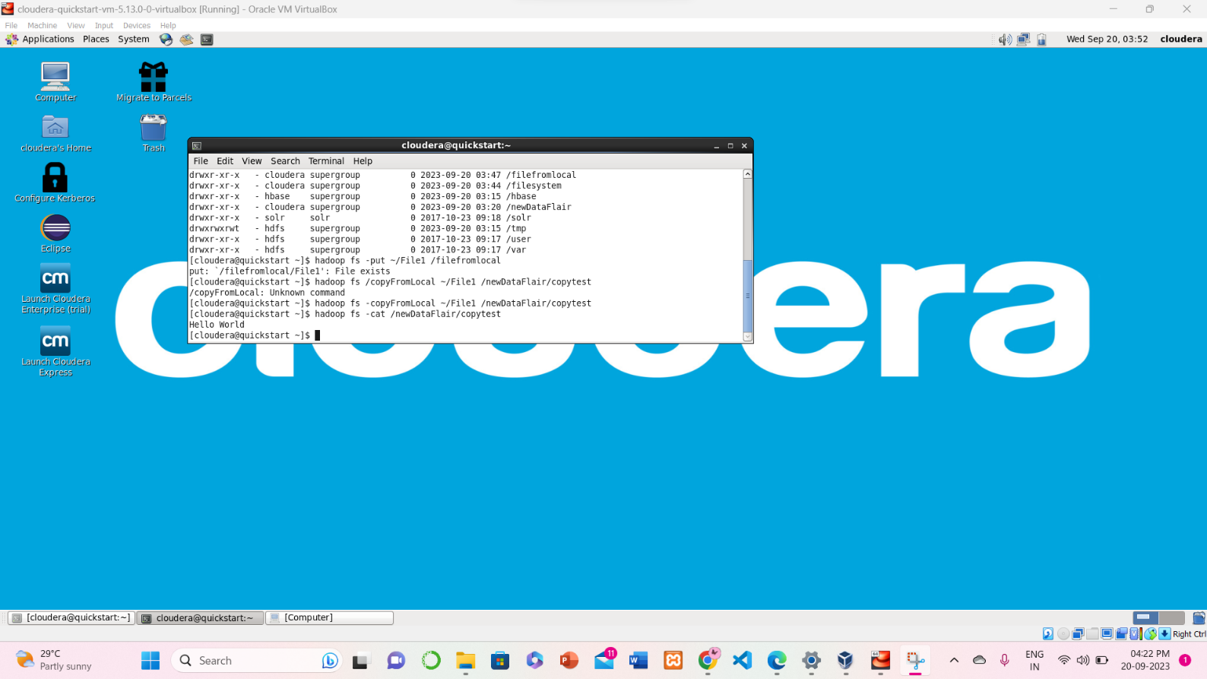

# get

## Hadoop HDFS get Command Usage:

hadoop fs -get <src> <localdest>

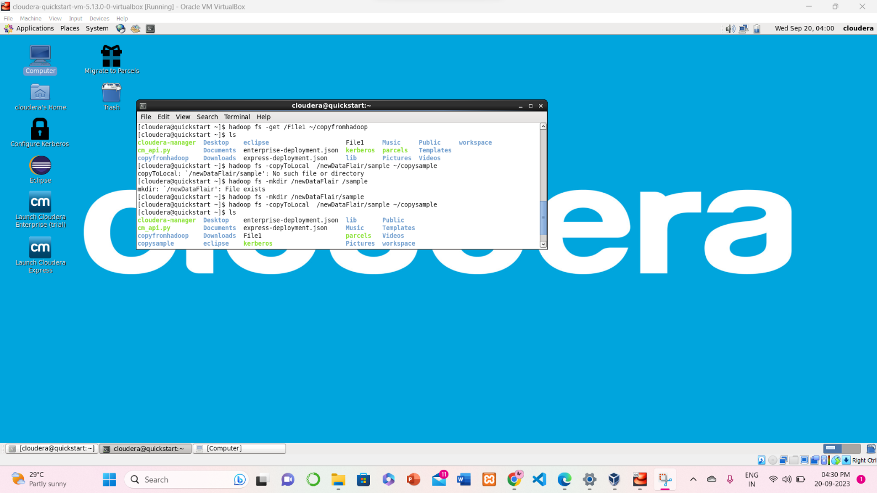

# copyToLocal

## Hadoop HDFS copyToLocal Command Usage:

hadoop fs -copyToLocal <hdfs source> <localdst>

## Hadoop HDFS copyToLocal Description:

**copyToLocal** command copies the file from HDFS to the local file system.



# cat

## Hadoop HDFS cat Command Usage:

hadoop fs –cat /path_to_file_in_hdfs



# mv

## Hadoop HDFS mv Command Usage:

hadoop fs -mv <src> <dest>

## Hadoop HDFS mv Command Description:

The HDFS mv command moves the files or directories from the source to a destination within

[**HDFS**](https://data-flair.training/blogs/comprehensive-hdfs-guide-introduction-architecture-data-read-write-tutorial/)**.**

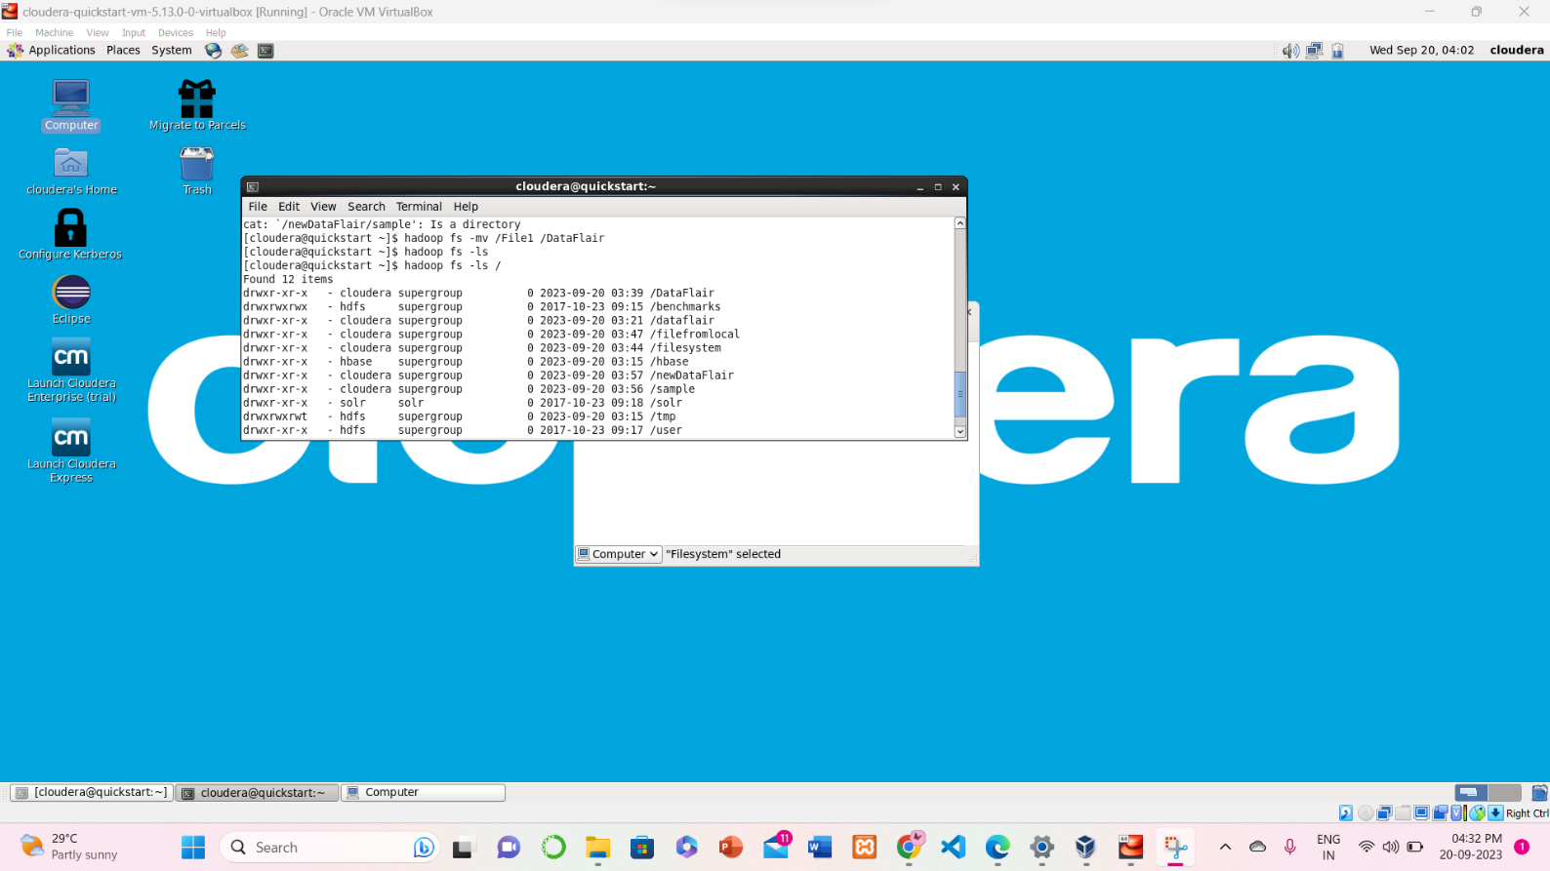

# cp

## Hadoop HDFS cp Command Usage:

hadoop fs -cp <src> <dest>

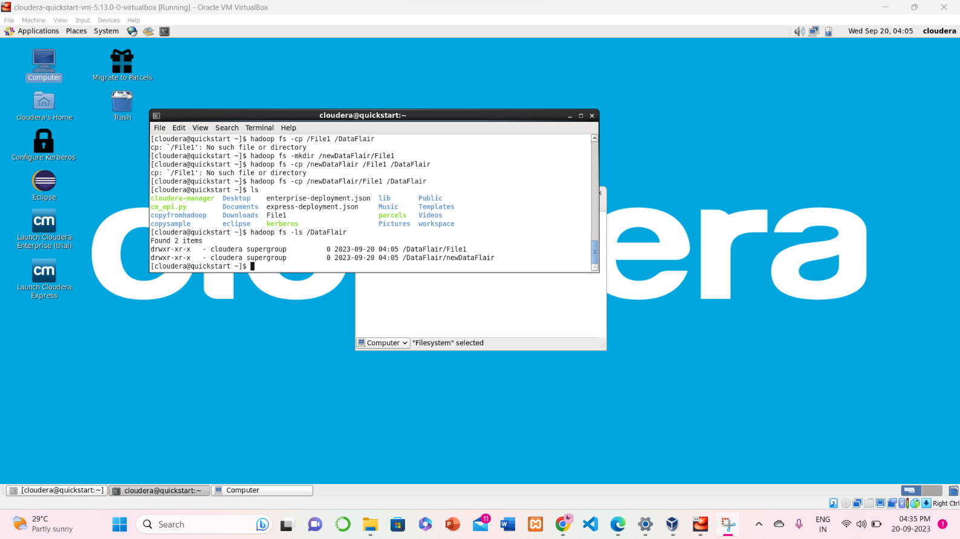

## Hadoop HDFS cp Command Example:

In the below example we are copying the ‘file1’ present in newDataFlair directory in HDFS to the dataflair directory of HDFS.

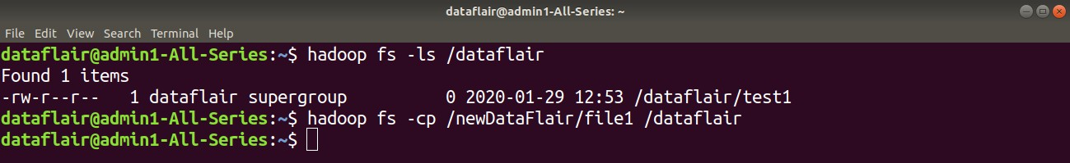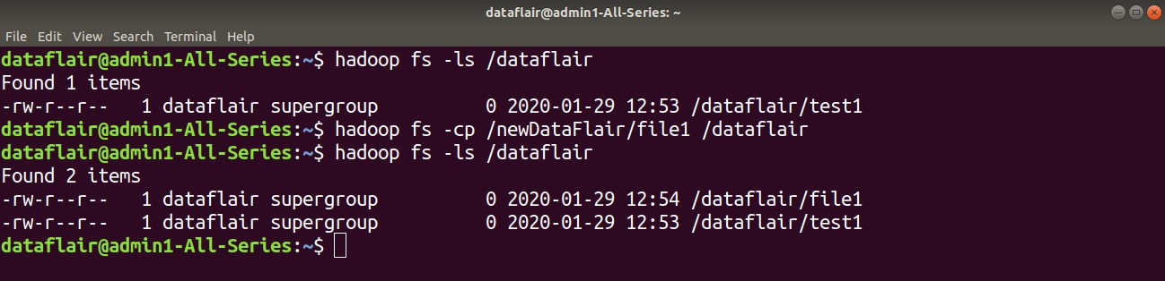

## Hadoop HDFS cp Command Description:

The **cp** command copies a file from one directory to another directory within the HDFS. So this was all on Hadoop HDFS Commands. Hope you like it.